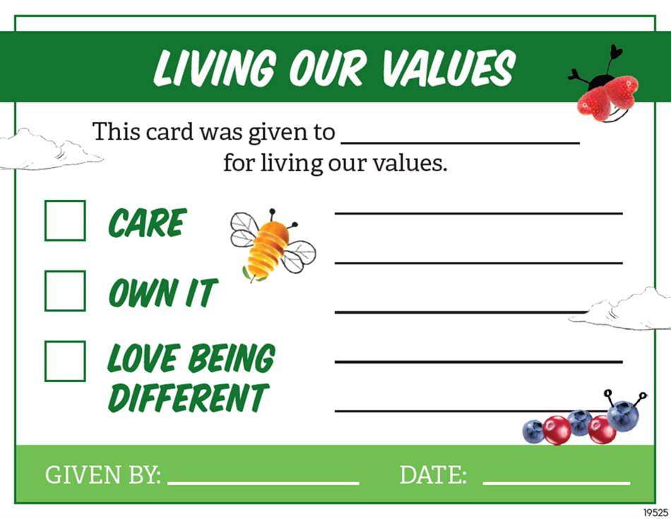
X
Add your name here
Add date
Add recipient name here
Add message here

